**Universidad de Sonora**



**Nombres:** Malcom Hiram Navarro López

José Vicente Zamora Félix

**Nombre del maestro:** Rodrigo Meléndez Amavizca

**Nombre de la materia:** Diseño de Sistemas Digitales

**Nombre de la practica:** Practica 9: Mensaje con display de 16 segmentos (50 – 60 caracteres)

**Semestre:** 2020-2

**Fecha:** Viernes/16/Octubre/2020

**Objetivo.**

Elaborar mensaje con display de 16 segmentos.

**Consideraciones teóricas.**

Anteriormente, realizamos una practica en la que realizamos un mensaje compuesto por letras mostradas en displays.

Cabe mencionar que este mensaje estaba compuesto por 20 – 30 caracteres o letras, las cuales eran expresadas por medio de los displays que a su vez expresaban las letras del mensaje mediante las compuertas lógicas que estaban conectadas entre si y daban lugar a las letras contenidas en el mensaje.

Como pudimos ver, el mensaje era algo muy sencillo, algo que era de requisito para la práctica, pues solo se buscaba demostrar algo muy sencillo mediante un proceso un poco elaborado, sin embargo, así como eso fue una demostración un poco sencilla, en esta ocasión realizaremos la misma secuencia de la practica anterior solo que ahora añadiremos unos cuantos caracteres más, un poco mas del doble de las que usamos en la practica 8

**Materiales:**

**1) 11 Displays de 16 segmentos**

**2) 1 DIP 4024**

**3) 8 Compuertas NOT**

**4) 129 Compuertas AND**

**5) 33 Compuertas OR**

**6) 1 Compuerta NAND**

**7) 1 Reloj (Clock)**

**8) 20 Flip flops 74273**

**Construcción y resultados.**

Construimos una tabla la cual muestra los valores que

|  |  |  |  |  |  |  |  |  |  |  |  |  |  |  |  |  |  |  |  |  |  |  |  |
| --- | --- | --- | --- | --- | --- | --- | --- | --- | --- | --- | --- | --- | --- | --- | --- | --- | --- | --- | --- | --- | --- | --- | --- |
| Display | A | B | C | D | E | F | G | a | b | c | d | e | f | g | h | i | j | k | l | m | n | o | p |
|  |
| I | 0 | 0 | 0 | 0 | 0 | 0 | 0 | 1 | 1 | 0 | 0 | 1 | 1 | 0 | 0 | 0 | 1 | 0 | 0 | 0 | 0 | 1 | 0 |  |
| A | 0 | 0 | 0 | 0 | 0 | 0 | 1 | 1 | 1 | 1 | 1 | 0 | 0 | 1 | 1 | 0 | 0 | 0 | 1 | 1 | 0 | 0 | 0 |  |
| I | 0 | 0 | 0 | 0 | 0 | 1 | 0 | 1 | 1 | 0 | 0 | 1 | 1 | 0 | 0 | 0 | 1 | 0 | 0 | 0 | 0 | 1 | 0 |  |
| N | 0 | 0 | 0 | 0 | 0 | 1 | 1 | 0 | 0 | 1 | 1 | 0 | 0 | 1 | 1 | 1 | 0 | 0 | 0 | 0 | 0 | 0 | 1 |  |
| COMILLA | 0 | 0 | 0 | 0 | 1 | 0 | 0 | 0 | 0 | 0 | 0 | 0 | 0 | 0 | 0 | 1 | 0 | 0 | 0 | 0 | 0 | 0 | 0 |  |
| T | 0 | 0 | 0 | 0 | 1 | 0 | 1 | 1 | 1 | 0 | 0 | 0 | 0 | 0 | 0 | 0 | 1 | 0 | 0 | 0 | 0 | 1 | 0 |  |
| ESPACIO | 0 | 0 | 0 | 0 | 1 | 1 | 0 | 0 | 0 | 0 | 0 | 0 | 0 | 0 | 0 | 0 | 0 | 0 | 0 | 0 | 0 | 0 | 0 |  |
| H | 0 | 0 | 0 | 0 | 1 | 1 | 1 | 0 | 0 | 1 | 1 | 0 | 0 | 1 | 1 | 0 | 0 | 0 | 1 | 1 | 0 | 0 | 0 |  |
| A | 0 | 0 | 0 | 1 | 0 | 0 | 0 | 1 | 1 | 1 | 1 | 0 | 0 | 1 | 1 | 0 | 0 | 0 | 1 | 1 | 0 | 0 | 0 |  |
| P | 0 | 0 | 0 | 1 | 0 | 0 | 1 | 1 | 1 | 1 | 0 | 0 | 0 | 1 | 1 | 0 | 0 | 0 | 1 | 1 | 0 | 0 | 0 |  |
| P | 0 | 0 | 0 | 1 | 0 | 1 | 0 | 1 | 1 | 1 | 0 | 0 | 0 | 1 | 1 | 0 | 0 | 0 | 1 | 1 | 0 | 0 | 0 |  |
| Y | 0 | 0 | 0 | 1 | 0 | 1 | 1 | 0 | 0 | 1 | 0 | 0 | 0 | 0 | 1 | 0 | 0 | 0 | 1 | 1 | 0 | 1 | 0 |  |
| ESPACIO | 0 | 0 | 0 | 1 | 1 | 0 | 0 | 0 | 0 | 0 | 0 | 0 | 0 | 0 | 0 | 0 | 0 | 0 | 0 | 0 | 0 | 0 | 0 |  |
| I | 0 | 0 | 0 | 1 | 1 | 0 | 1 | 1 | 1 | 0 | 0 | 1 | 1 | 0 | 0 | 0 | 1 | 0 | 0 | 0 | 0 | 1 | 0 |  |
| COMILLA | 0 | 0 | 0 | 1 | 1 | 1 | 0 | 0 | 0 | 0 | 0 | 0 | 0 | 0 | 0 | 1 | 0 | 0 | 0 | 0 | 0 | 0 | 0 |  |
| M | 0 | 0 | 0 | 1 | 1 | 1 | 1 | 0 | 0 | 1 | 1 | 0 | 0 | 1 | 1 | 1 | 0 | 1 | 0 | 0 | 0 | 0 | 0 |  |
| ESPACIO | 0 | 0 | 1 | 0 | 0 | 0 | 0 | 0 | 0 | 0 | 0 | 0 | 0 | 0 | 0 | 0 | 0 | 0 | 0 | 0 | 0 | 0 | 0 |  |
| F | 0 | 0 | 1 | 0 | 0 | 0 | 1 | 1 | 1 | 0 | 0 | 0 | 0 | 1 | 1 | 0 | 0 | 0 | 1 | 1 | 0 | 0 | 0 |  |
| E | 0 | 0 | 1 | 0 | 0 | 1 | 0 | 1 | 1 | 0 | 0 | 1 | 1 | 1 | 1 | 0 | 0 | 0 | 1 | 1 | 0 | 0 | 0 |  |
| E | 0 | 0 | 1 | 0 | 0 | 1 | 1 | 1 | 1 | 0 | 0 | 1 | 1 | 1 | 1 | 0 | 0 | 0 | 1 | 1 | 0 | 0 | 0 |  |
| L | 0 | 0 | 1 | 0 | 1 | 0 | 0 | 0 | 0 | 0 | 0 | 1 | 1 | 1 | 1 | 0 | 0 | 0 | 0 | 0 | 0 | 0 | 0 |  |
| I | 0 | 0 | 1 | 0 | 1 | 0 | 1 | 1 | 1 | 0 | 0 | 1 | 1 | 0 | 0 | 0 | 1 | 0 | 0 | 0 | 0 | 1 | 0 |  |
| N | 0 | 0 | 1 | 0 | 1 | 1 | 0 | 0 | 0 | 1 | 1 | 0 | 0 | 1 | 1 | 1 | 0 | 0 | 0 | 0 | 0 | 0 | 1 |  |
| G | 0 | 0 | 1 | 0 | 1 | 1 | 1 | 1 | 1 | 0 | 1 | 1 | 1 | 1 | 1 | 0 | 0 | 0 | 0 | 1 | 0 | 0 | 0 |  |
| ESPACIO | 0 | 0 | 1 | 1 | 0 | 0 | 0 | 0 | 0 | 0 | 0 | 0 | 0 | 0 | 0 | 0 | 0 | 0 | 0 | 0 | 0 | 0 | 0 |  |
| G | 0 | 0 | 1 | 1 | 0 | 0 | 1 | 1 | 1 | 0 | 1 | 1 | 1 | 1 | 1 | 0 | 0 | 0 | 0 | 1 | 0 | 0 | 0 |  |
| L | 0 | 0 | 1 | 1 | 0 | 1 | 0 | 0 | 0 | 0 | 0 | 1 | 1 | 1 | 1 | 0 | 0 | 0 | 0 | 0 | 0 | 0 | 0 |  |
| A | 0 | 0 | 1 | 1 | 0 | 1 | 1 | 1 | 1 | 1 | 1 | 0 | 0 | 1 | 1 | 0 | 0 | 0 | 1 | 1 | 0 | 0 | 0 |  |
| D | 0 | 0 | 1 | 1 | 1 | 0 | 0 | 1 | 1 | 1 | 1 | 1 | 1 | 0 | 0 | 0 | 1 | 0 | 0 | 0 | 0 | 1 | 0 |  |
| ESPACIO | 0 | 0 | 1 | 1 | 1 | 0 | 1 | 0 | 0 | 0 | 0 | 0 | 0 | 0 | 0 | 0 | 0 | 0 | 0 | 0 | 0 | 0 | 0 |  |
| I | 0 | 0 | 1 | 1 | 1 | 1 | 0 | 1 | 1 | 0 | 0 | 1 | 1 | 0 | 0 | 0 | 1 | 0 | 0 | 0 | 0 | 1 | 0 |  |
| ESPACIO | 0 | 0 | 1 | 1 | 1 | 1 | 1 | 0 | 0 | 0 | 0 | 0 | 0 | 0 | 0 | 0 | 0 | 0 | 0 | 0 | 0 | 0 | 0 |  |
| G | 0 | 1 | 0 | 0 | 0 | 0 | 0 | 1 | 1 |  | 1 | 1 | 1 | 1 | 1 |  |  |  |  | 1 | 0 | 0 | 0 |  |
| O | 0 | 1 | 0 | 0 | 0 | 0 | 1 | 1 | 1 | 1 | 1 | 1 | 1 | 1 | 1 |  |  |  |  |  | 0 | 0 | 0 |  |
| T | 0 | 1 | 0 | 0 | 0 | 1 | 0 | 1 | 1 |  |  |  |  |  |  |  | 1 |  |  |  | 0 | 1 | 0 |  |
| ESPACIO | 0 | 1 | 0 | 0 | 0 | 1 | 1 |  |  |  |  |  |  |  |  |  |  |  |  |  | 0 | 0 | 0 |  |
| S | 0 | 1 | 0 | 0 | 1 | 0 | 0 | 1 | 1 |  | 1 | 1 | 1 |  | 1 |  |  |  | 1 | 1 | 0 | 0 | 0 |  |
| U | 0 | 1 | 0 | 0 | 1 | 0 | 1 |  |  | 1 | 1 | 1 | 1 | 1 | 1 |  |  |  |  |  | 0 | 0 | 0 |  |
| N | 0 | 1 | 0 | 0 | 1 | 1 | 0 |  |  | 1 | 1 |  |  | 1 | 1 | 1 |  |  |  |  | 0 | 0 | 1 |  |
| S | 0 | 1 | 0 | 0 | 1 | 1 | 1 | 1 | 1 |  | 1 | 1 | 1 |  | 1 |  |  |  | 1 | 1 | 0 | 0 | 0 |  |
| H | 0 | 1 | 0 | 1 | 0 | 0 | 0 |  |  | 1 | 1 |  |  | 1 | 1 |  |  |  | 1 | 1 | 0 | 0 | 0 |  |
| I | 0 | 1 | 0 | 1 | 0 | 0 | 1 | 1 | 1 |  |  | 1 | 1 |  |  |  | 1 |  |  |  | 0 | 1 | 0 |  |
| N | 0 | 1 | 0 | 1 | 0 | 1 | 0 |  |  | 1 | 1 |  |  | 1 | 1 | 1 |  |  |  |  | 0 | 0 | 1 |  |
| E | 0 | 1 | 0 | 1 | 0 | 1 | 1 | 1 | 1 |  |  | 1 | 1 | 1 | 1 |  |  |  | 1 | 1 | 0 | 0 | 0 |  |
| ESPACIO | 0 | 1 | 0 | 1 | 1 | 0 | 0 |  |  |  |  |  |  |  |  |  |  |  |  |  | 0 | 0 | 0 |  |
| I | 0 | 1 | 0 | 1 | 1 | 0 | 1 | 1 | 1 |  |  | 1 | 1 |  |  |  | 1 |  |  |  | 0 | 1 | 0 |  |
| N | 0 | 1 | 0 | 1 | 1 | 1 | 0 |  |  | 1 | 1 |  |  | 1 | 1 | 1 |  |  |  |  | 0 | 0 | 1 |  |
| ESPACIO | 0 | 1 | 0 | 1 | 1 | 1 | 1 |  |  |  |  |  |  |  |  |  |  |  |  |  | 0 | 0 | 0 |  |
| A | 0 | 1 | 1 | 0 | 0 | 0 | 0 | 1 | 1 | 1 | 1 |  |  | 1 | 1 |  |  |  | 1 | 1 | 0 | 0 | 0 |  |
| ESPACIO | 0 | 1 | 1 | 0 | 0 | 0 | 1 |  |  |  |  |  |  |  |  |  |  |  |  |  | 0 | 0 | 0 |  |
| B | 0 | 1 | 1 | 0 | 0 | 1 | 0 | 1 | 1 | 1 | 1 | 1 | 1 |  |  | 1 |  |  |  | 1 | 0 | 1 | 0 |  |
| A | 0 | 1 | 1 | 0 | 0 | 1 | 1 | 1 | 1 | 1 | 1 |  |  | 1 | 1 |  |  |  | 1 | 1 | 0 | 0 | 0 |  |
| G | 0 | 1 | 1 | 0 | 1 | 0 | 0 | 1 | 1 |  | 1 | 1 | 1 | 1 | 1 |  |  |  | 0 | 1 | 0 | 0 | 0 |  |
| ESPACIO | 0 | 1 | 1 | 0 | 1 | 0 | 1 |  |  |  |  |  |  |  |  |  |  |  | 0 | 0 | 0 | 0 | 0 |  |
| I | 0 | 1 | 1 | 0 | 1 | 1 | 0 | 1 | 1 |  |  | 1 | 1 |  |  |  | 1 |  | 0 | 0 | 0 | 1 | 0 |  |
| COMILLA | 0 | 1 | 1 | 0 | 1 | 1 | 1 |  |  |  |  |  |  |  |  | 1 |  |  | 0 | 0 | 0 | 0 | 0 |  |
| M | 0 | 1 | 1 | 1 | 0 | 0 | 0 |  |  | 1 | 1 |  |  | 1 | 1 | 1 |  | 1 | 0 | 0 | 0 | 0 | 0 |  |
| ESPACIO | 0 | 1 | 1 | 1 | 0 | 0 | 1 |  |  |  |  |  |  |  |  |  |  |  | 0 | 0 | 0 | 0 | 0 |  |
| U | 0 | 1 | 1 | 1 | 0 | 1 | 0 |  |  | 1 | 1 | 1 | 1 | 1 | 1 |  |  |  | 0 | 0 | 0 | 0 | 0 |  |
| S | 0 | 1 | 1 | 1 | 0 | 1 | 1 | 1 | 1 |  | 1 | 1 | 1 |  | 1 |  |  |  | 1 | 1 | 0 | 0 | 0 |  |
| E | 0 | 1 | 1 | 1 | 1 | 0 | 0 | 1 | 1 |  |  | 1 | 1 | 1 | 1 |  |  |  | 1 | 1 | 0 | 0 | 0 |  |
| L | 0 | 1 | 1 | 1 | 1 | 0 | 1 |  |  |  |  | 1 | 1 | 1 | 1 |  |  |  | 0 | 0 | 0 | 0 | 0 |  |
| E | 0 | 1 | 1 | 1 | 1 | 1 | 0 | 1 | 1 |  |  | 1 | 1 | 1 | 1 |  |  |  | 1 | 1 | 0 | 0 | 0 |  |
| S | 0 | 0 | 1 | 1 | 1 | 1 | 1 | 1 | 1 |  | 1 | 1 | 1 |  | 1 |  |  |  | 1 | 1 | 0 | 0 | 0 |  |
| s | 1 | 0 | 0 | 0 | 0 | 0 | 0 | 1 | 1 |  | 1 | 1 | 1 |  | 1 |  |  |  | 1 | 1 | 0 | 0 | 0 |  |
| ESPACIO | 1 | 0 | 0 | 0 | 0 | 0 | 1 | X | X | 0 | 0 | 0 | 0 | 0 | 0 | 0 | 0 | 0 | 0 | 0 | 0 | 0 | 0 |  |
|  |  |  |  |  |  |  |  | X | X | X | X | X | X | X | X | X | X | X | X | X | X | X | X |  |
|  |  |  |  |  |  |  |  | X | X | X | X | X | X | X | X | X | X | X | X | X | X | X | X |  |
|  |  |  |  |  |  |  |  | X | X | X | X | X | X | X | X | X | X | X | X | X | X | X | X |  |
|  |  |  |  |  |  |  |  | X | X | X | X | X | X | X | X | X | X | X | X | X | X | X | X |  |
|  |  |  |  |  |  |  |  | X | X | X | X | X | X | X | X | X | X | X | X | X | X | X | X |  |
|  |  |  |  |  |  |  |  | X | X | X | X | X | X | X | X | X | X | X | X | X | X | X | X |  |
|  |  |  |  |  |  |  |  | X | X | X | X | X | X | X | X | X | X | X | X | X | X | X | X |  |
|  |  |  |  |  |  |  |  | X | X | X | X | X | X | X | X | X | X | X | X | X | X | X | X |  |
|  |  |  |  |  |  |  |  | X | X | X | X | X | X | X | X | X | X | X | X | X | X | X | X |  |
|  |  |  |  |  |  |  |  | X | X | X | X | X | X | X | X | X | X | X | X | X | X | X | X |  |
|  |  |  |  |  |  |  |  | X | X | X | X | X | X | X | X | X | X | X | X | X | X | X | X |  |
|  |  |  |  |  |  |  |  | X | X | X | X | X | X | X | X | X | X | X | X | X | X | X | X |  |
|  |  |  |  |  |  |  |  | X | X | X | X | X | X | X | X | X | X | X | X | X | X | X | X |  |
|  |  |  |  |  |  |  |  | X | X | X | X | X | X | X | X | X | X | X | X | X | X | X | X |  |
|  |  |  |  |  |  |  |  | X | X | X | X | X | X | X | X | X | X | X | X | X | X | X | X |  |
|  |  |  |  |  |  |  |  | X | X | X | X | X | X | X | X | X | X | X | X | X | X | X | X |  |
|  |  |  |  |  |  |  |  | X | X | X | X | X | X | X | X | X | X | X | X | X | X | X | X |  |
|  |  |  |  |  |  |  |  | X | X | X | X | X | X | X | X | X | X | X | X | X | X | X | X |  |
|  |  |  |  |  |  |  |  | X | X | X | X | X | X | X | X | X | X | X | X | X | X | X | X |  |
|  |  |  |  |  |  |  |  | X | X | X | X | X | X | X | X | X | X | X | X | X | X | X | X |  |
|  |  |  |  |  |  |  |  | X | X | X | X | X | X | X | X | X | X | X | X | X | X | X | X |  |
|  |  |  |  |  |  |  |  | X | X | X | X | X | X | X | X | X | X | X | X | X | X | X | X |  |
|  |  |  |  |  |  |  |  | X | X | X | X | X | X | X | X | X | X | X | X | X | X | X | X |  |
|  |  |  |  |  |  |  |  | X | X | X | X | X | X | X | X | X | X | X | X | X | X | X | X |  |
|  |  |  |  |  |  |  |  | X | X | X | X | X | X | X | X | X | X | X | X | X | X | X | X |  |
|  |  |  |  |  |  |  |  | X | X | X | X | X | X | X | X | X | X | X | X | X | X | X | X |  |
|  |  |  |  |  |  |  |  | X | X | X | X | X | X | X | X | X | X | X | X | X | X | X | X |  |
|  |  |  |  |  |  |  |  | X | X | X | X | X | X | X | X | X | X | X | X | X | X | X | X |  |
|  |  |  |  |  |  |  |  | X | X | X | X | X | X | X | X | X | X | X | X | X | X | X | X |  |
|  |  |  |  |  |  |  |  | X | X | X | X | X | X | X | X | X | X | X | X | X | X | X | X |  |
|  |  |  |  |  |  |  |  | X | X | X | X | X | X | X | X | X | X | X | X | X | X | X | X |  |
|  |  |  |  |  |  |  |  | X | X | X | X | X | X | X | X | X | X | X | X | X | X | X | X |  |
|  |  |  |  |  |  |  |  | X | X | X | X | X | X | X | X | X | X | X | X | X | X | X | X |  |
|  |  |  |  |  |  |  |  | X | X | X | X | X | X | X | X | X | X | X | X | X | X | X | X |  |
|  |  |  |  |  |  |  |  | X | X | X | X | X | X | X | X | X | X | X | X | X | X | X | X |  |
|  |  |  |  |  |  |  |  | X | X | X | X | X | X | X | X | X | X | X | X | X | X | X | X |  |
|  |  |  |  |  |  |  |  | X | X | X | X | X | X | X | X | X | X | X | X | X | X | X | X |  |
|  |  |  |  |  |  |  |  | X | X | X | X | X | X | X | X | X | X | X | X | X | X | X | X |  |
|  |  |  |  |  |  |  |  | X | X | X | X | X | X | X | X | X | X | X | X | X | X | X | X |  |
|  |  |  |  |  |  |  |  | X | X | X | X | X | X | X | X | X | X | X | X | X | X | X | X |  |
|  |  |  |  |  |  |  |  | X | X | X | X | X | X | X | X | X | X | X | X | X | X | X | X |  |
|  |  |  |  |  |  |  |  | X | X | X | X | X | X | X | X | X | X | X | X | X | X | X | X |  |
|  |  |  |  |  |  |  |  | X | X | X | X | X | X | X | X | X | X | X | X | X | X | X | X |  |
|  |  |  |  |  |  |  |  | X | X | X | X | X | X | X | X | X | X | X | X | X | X | X | X |  |
|  |  |  |  |  |  |  |  | X | X | X | X | X | X | X | X | X | X | X | X | X | X | X | X |  |
|  |  |  |  |  |  |  |  | X | X | X | X | X | X | X | X | X | X | X | X | X | X | X | X |  |
|  |  |  |  |  |  |  |  | X | X | X | X | X | X | X | X | X | X | X | X | X | X | X | X |  |
|  |  |  |  |  |  |  |  | X | X | X | X | X | X | X | X | X | X | X | X | X | X | X | X |  |
|  |  |  |  |  |  |  |  | X | X | X | X | X | X | X | X | X | X | X | X | X | X | X | X |  |
|  |  |  |  |  |  |  |  | X | X | X | X | X | X | X | X | X | X | X | X | X | X | X | X |  |
|  |  |  |  |  |  |  |  | X | X | X | X | X | X | X | X | X | X | X | X | X | X | X | X |  |
|  |  |  |  |  |  |  |  | X | X | X | X | X | X | X | X | X | X | X | X | X | X | X | X |  |
|  |  |  |  |  |  |  |  | X | X | X | X | X | X | X | X | X | X | X | X | X | X | X | X |  |
|  |  |  |  |  |  |  |  | X | X | X | X | X | X | X | X | X | X | X | X | X | X | X | X |  |
|  |  |  |  |  |  |  |  | X | X | X | X | X | X | X | X | X | X | X | X | X | X | X | X |  |
|  |  |  |  |  |  |  |  | X | X | X | X | X | X | X | X | X | X | X | X | X | X | X | X |  |
|  |  |  |  |  |  |  |  | X | X | X | X | X | X | X | X | X | X | X | X | X | X | X | X |  |
|  |  |  |  |  |  |  |  | X | X | X | X | X | X | X | X | X | X | X | X | X | X | X | X |  |
|  |  |  |  |  |  |  |  | X | X | X | X | X | X | X | X | X | X | X | X | X | X | X | X |  |
|  |  |  |  |  |  |  |  | X | X | X | X | X | X | X | X | X | X | X | X | X | X | X | X |  |
|  |  |  |  |  |  |  |  | X | X | X | X | X | X | X | X | X | X | X | X | X | X | X | X |  |
|  |  |  |  |  |  |  |  | X | X | X | X | X | X | X | X | X | X | X | X | X | X | X | X |  |
|  |  |  |  |  |  |  |  | x | x | x | x | x | x | x | x | x | x | x | x | x | x | x | x |  |

**Simplificación**

Simplificamos lo que está en la tabla utilizando los mapas de Karnaugh.

**Minimizado de [A]Y [B]**

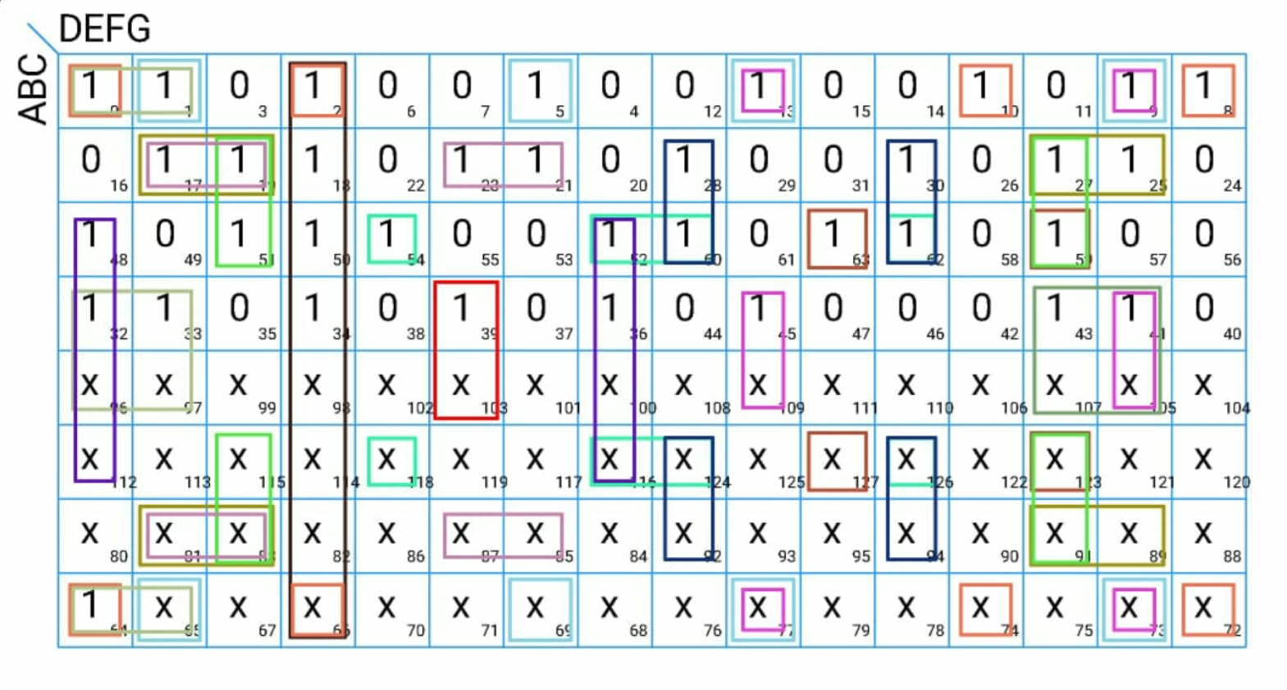



**SIMPLIFICACION [C]**

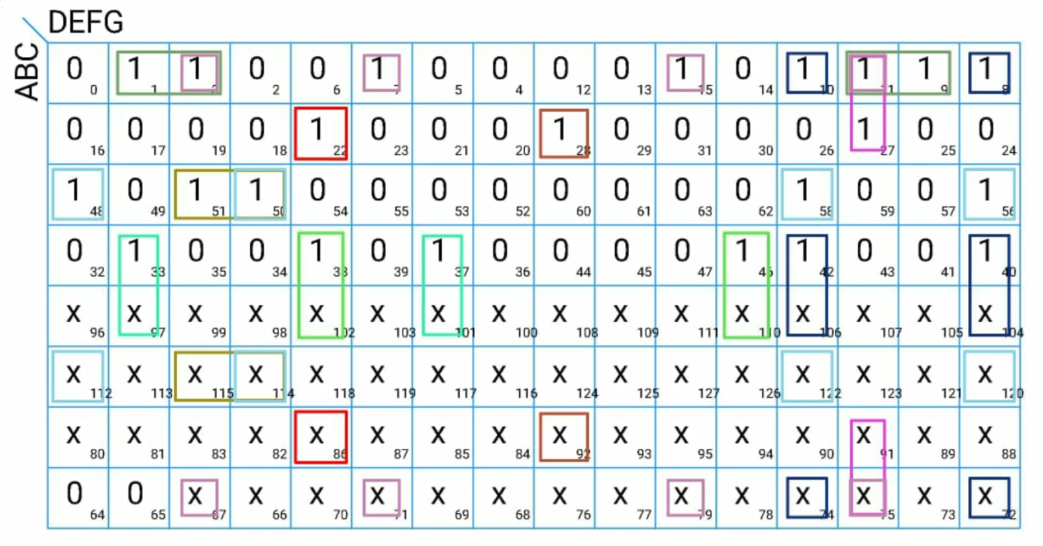



**SIMPLIFICACION DE [D]**

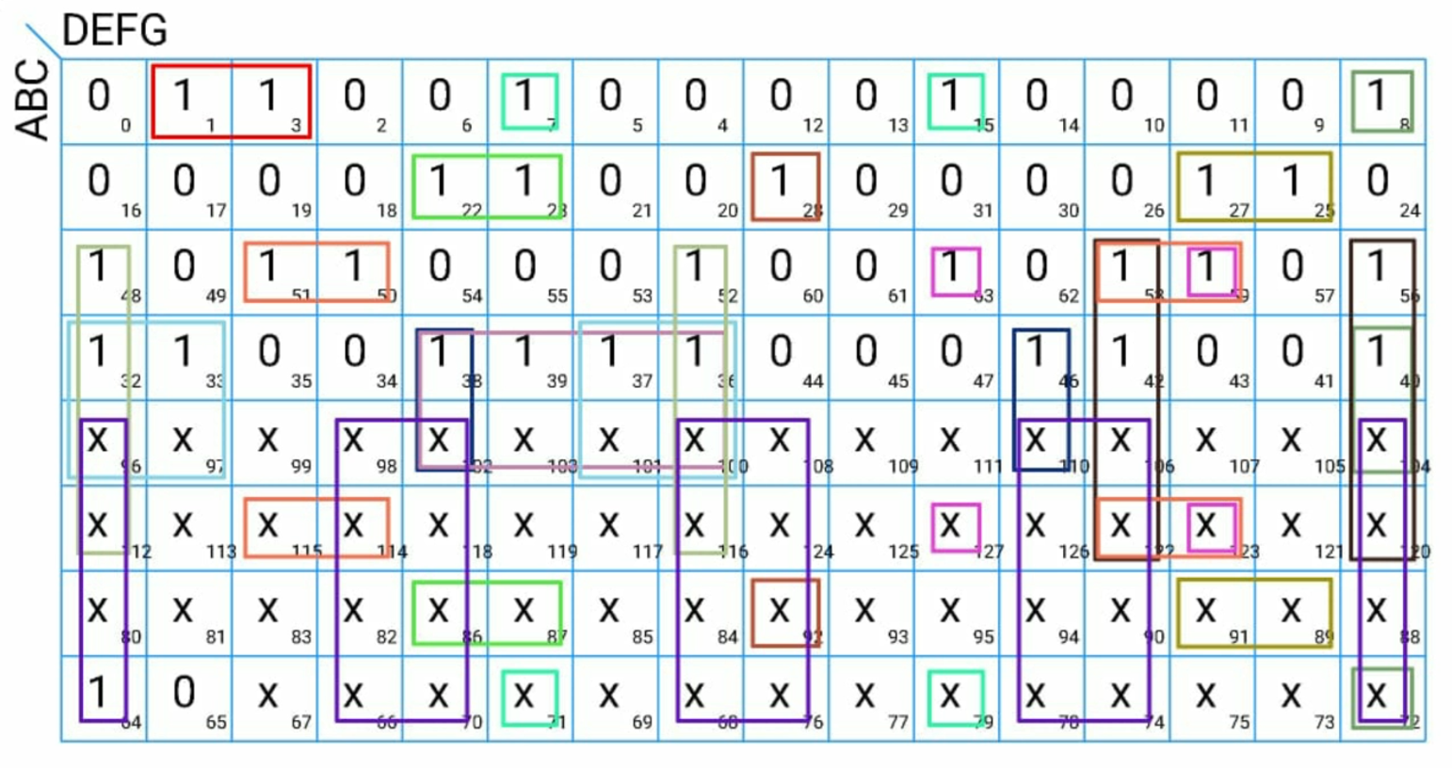



**SIMPLIFICACION DE [E] Y DE [F]**

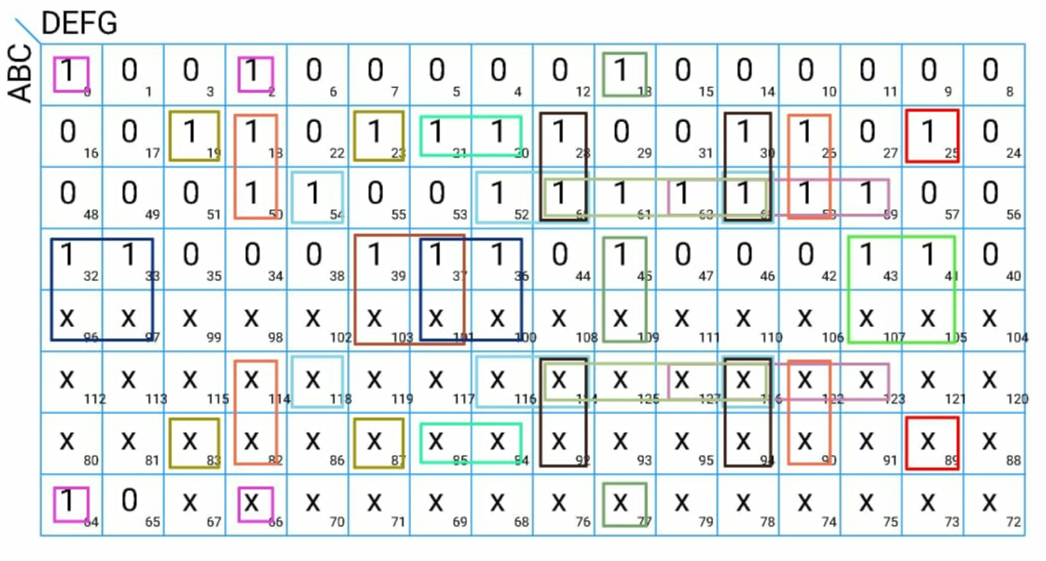



**SIMPLIFICACION DE [G]**

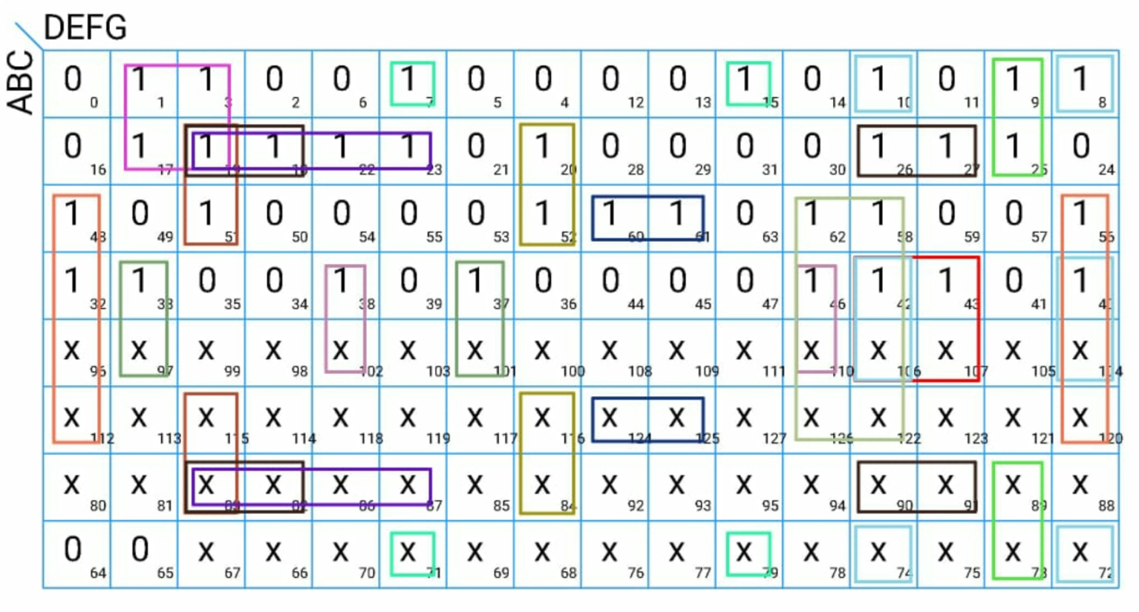



**SIMPLIFICACION [H]**

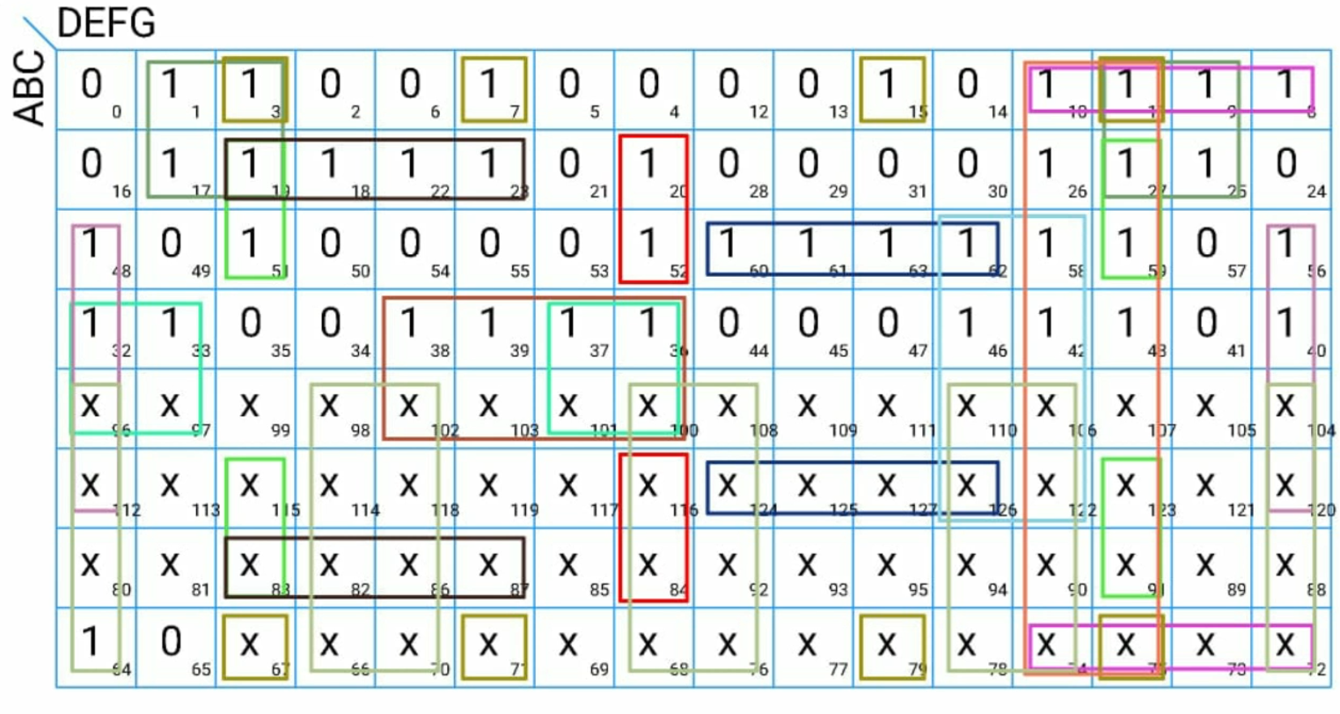



**SIMPLIFICACION [I]**

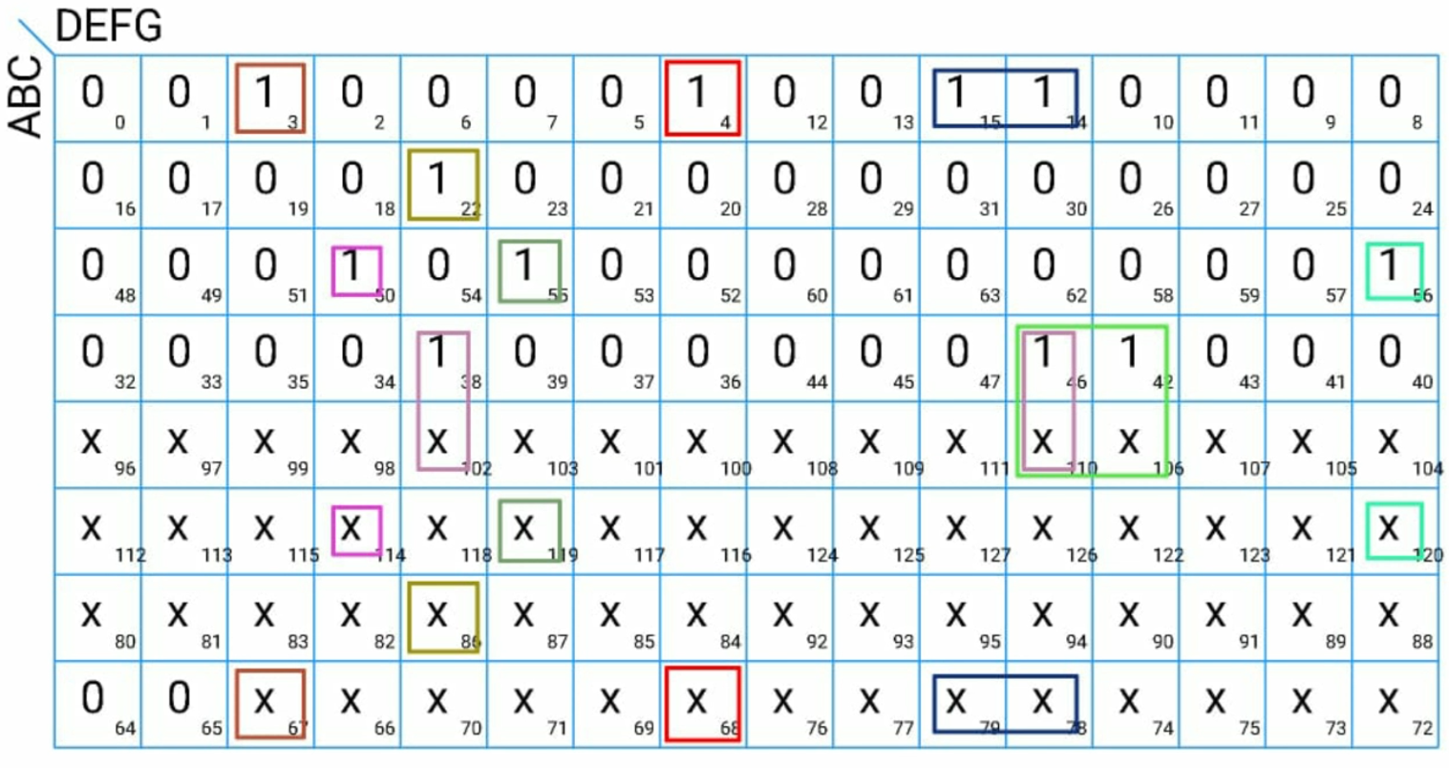



**SIMPLIFICACION [J]**

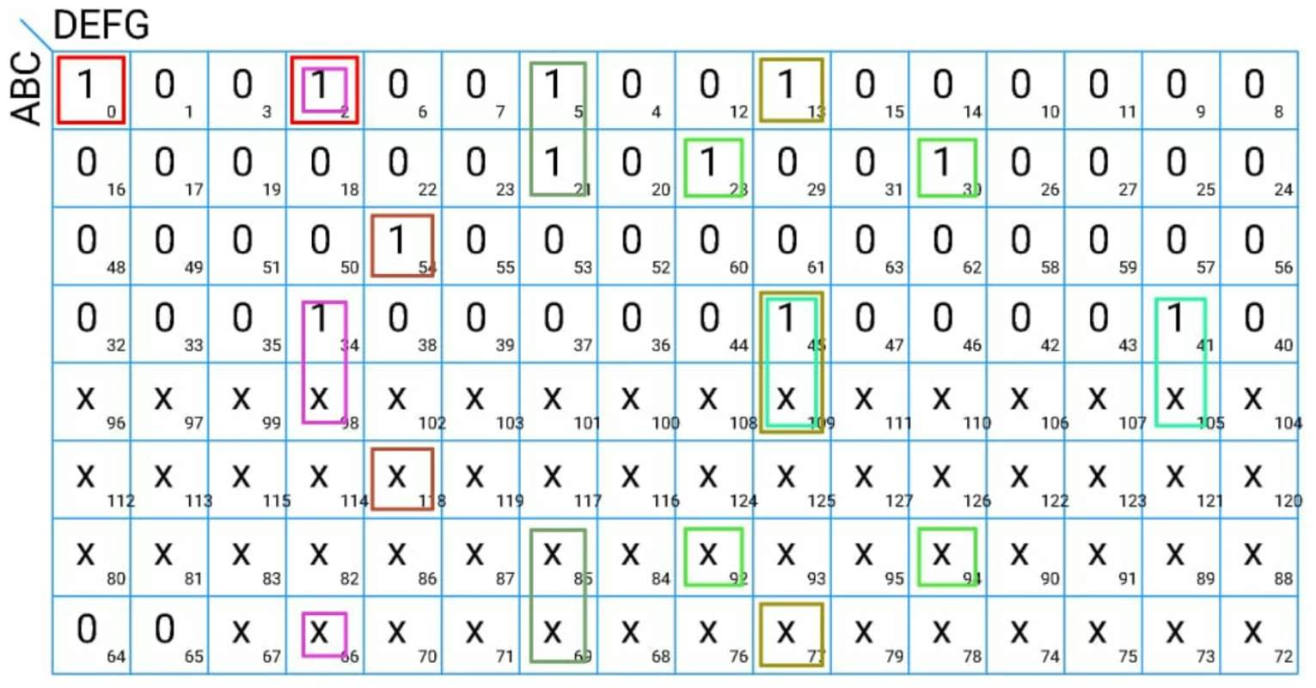



**SIMPLIFICACION [K]**

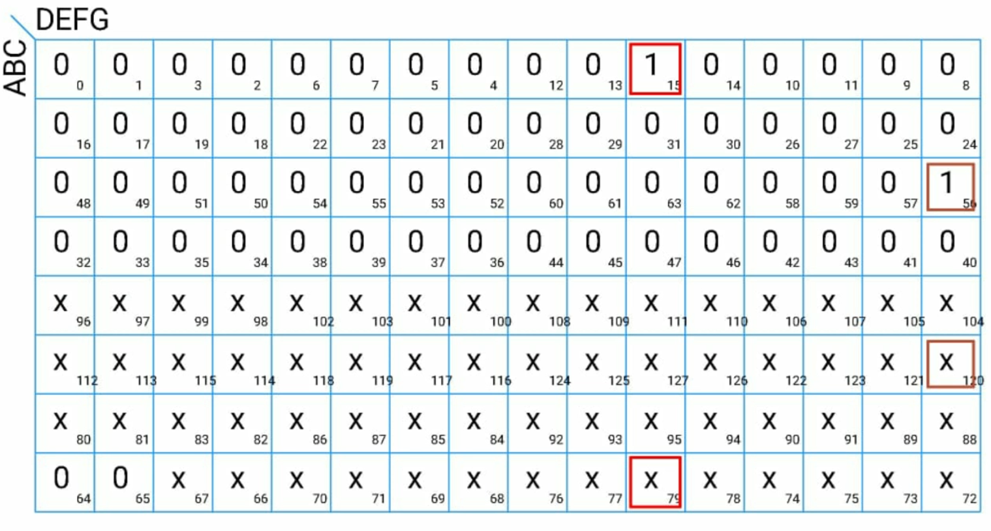



**SIMPLIFICACION [L]**

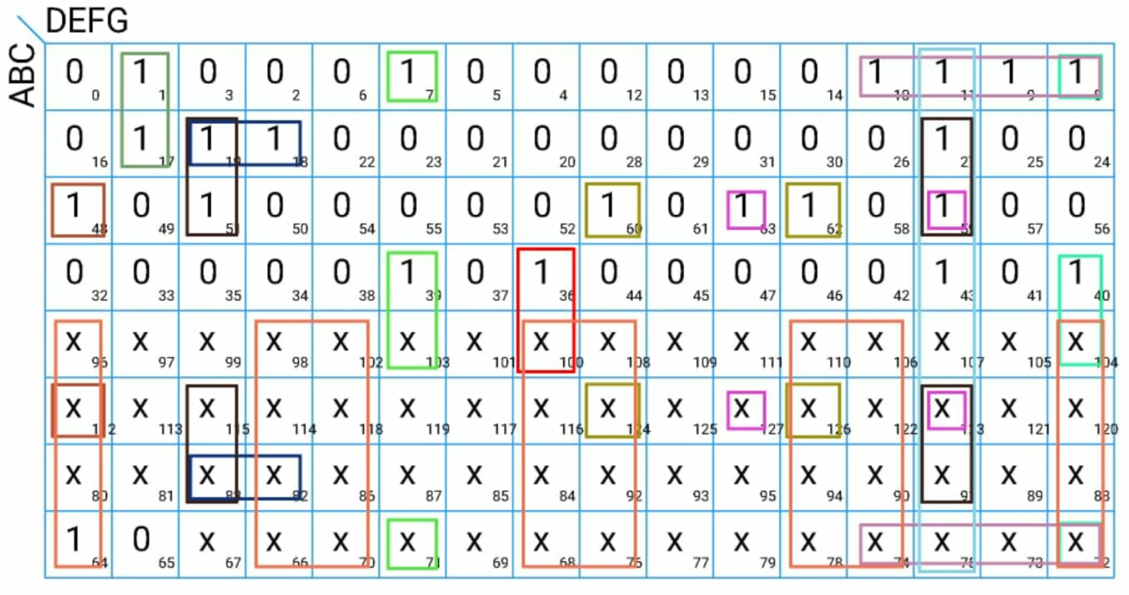



**SIMPLIFICACION [M]**

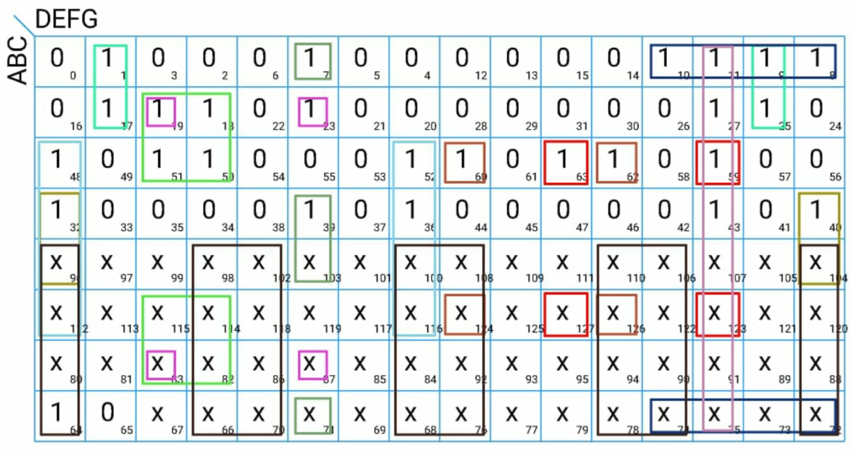



**SIMPLIFICACION DE [N] NO HAY ES IGUAL A CERO**

**SOMPLIFICACION DE[O]**

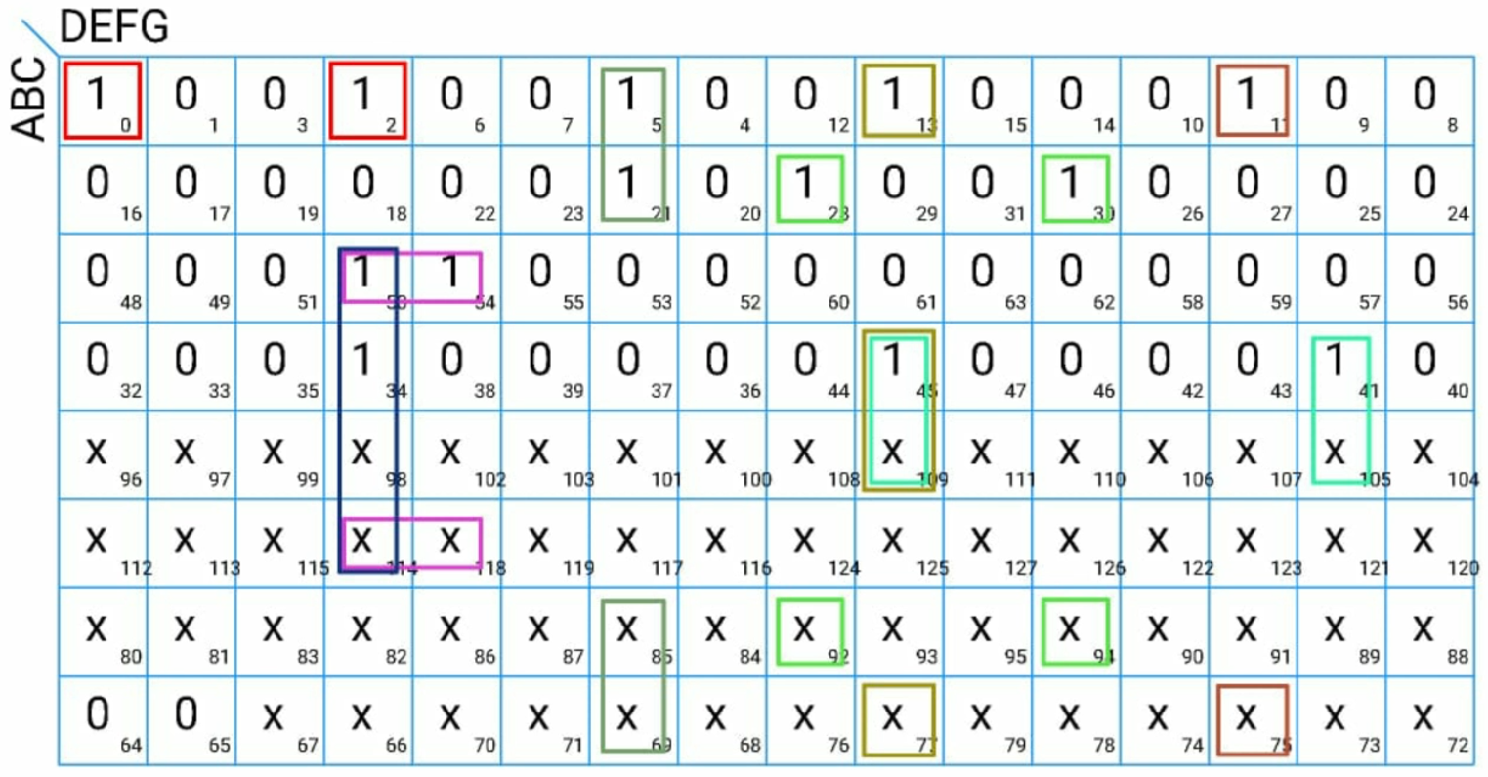



**SIMPLIFICACION DE [P]**

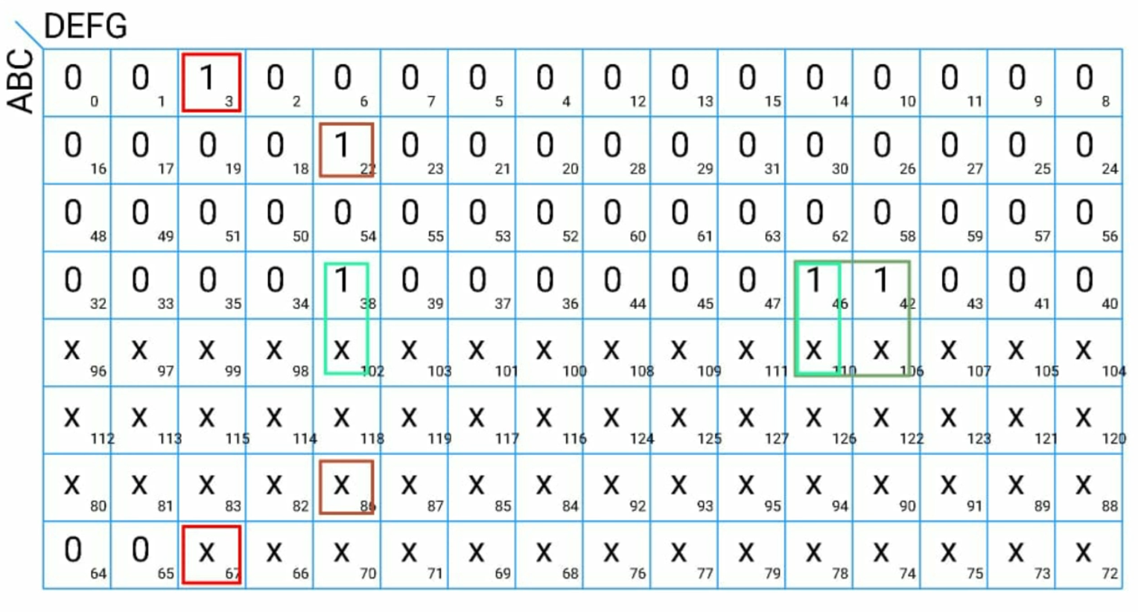



**Circuito Lógico**

Estas son las simplificaciones de la tabla y a su ves las salidas del circuito que irán al display de 16 segmentos.

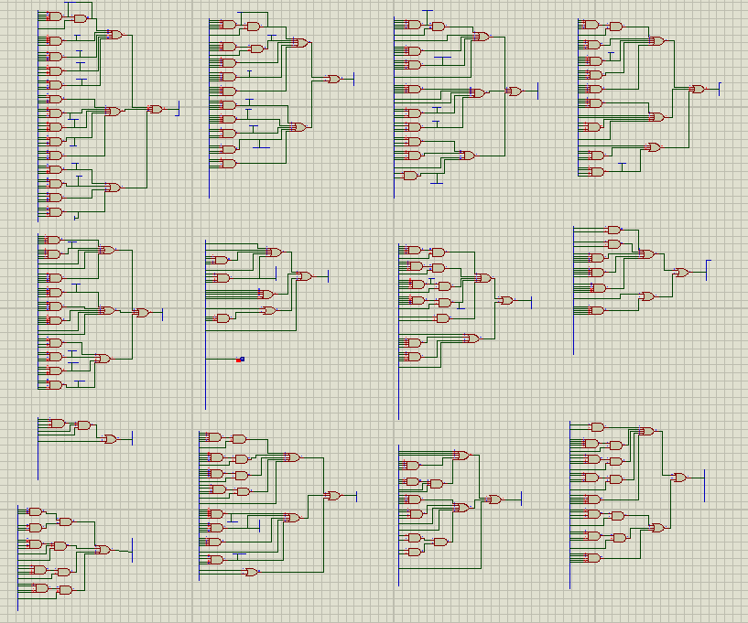

En la siguiente imagen se muestra los fil-flop y el mensaje del display.

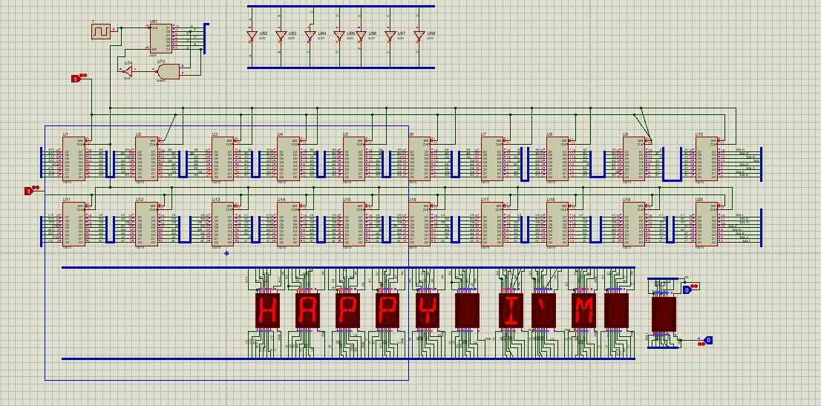

**Conclusión**

En esta práctica, hemos transmitido un mensaje por medio de displays, sin embargo, en esta ocasión decidimos mostrar un fragmento de una canción debido al numero de caracteres que debe contener el mensaje.

Como podemos ver, es un mensaje un poco más extenso que el que realizamos en la práctica anterior y por lo tanto, la cantidad de materiales y componentes utilizados es un poco mas extenso por lo mismo.

El texto que presentamos consta de alrededor de unos 50 o 60 caracteres, los cuales pertenecen a un verso de una canción del grupo musical llamado ‘Gorillaz’, esta canción se llama ‘Clint Eastwood’ y es una de las canciones más populares de la banda y fue lanzada en el año 2001, siendo esta una de las canciones mas reconocidas y antiguas del grupo musical.